Nate Harris
3/10/2025
Cis 2107
Lab 8
Q1: You would need to add the -g flag to your normal gcc compile
Q2: 0x7fffffffbe30
Q3: 0x7fffffffbe30
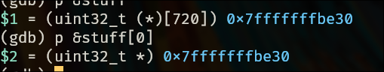

Q4: We would expect them to be the same, the [n] operator in c goes to the address n spots into the array. Since the address of the 0 spot in the array and the pointer that represents the array are the same, the address would be the same.
Q5: LAME_KEY
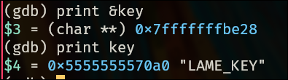

Q6: I used the print command, but it can also be found by stepping through the program.
Q7: i=4 j=256
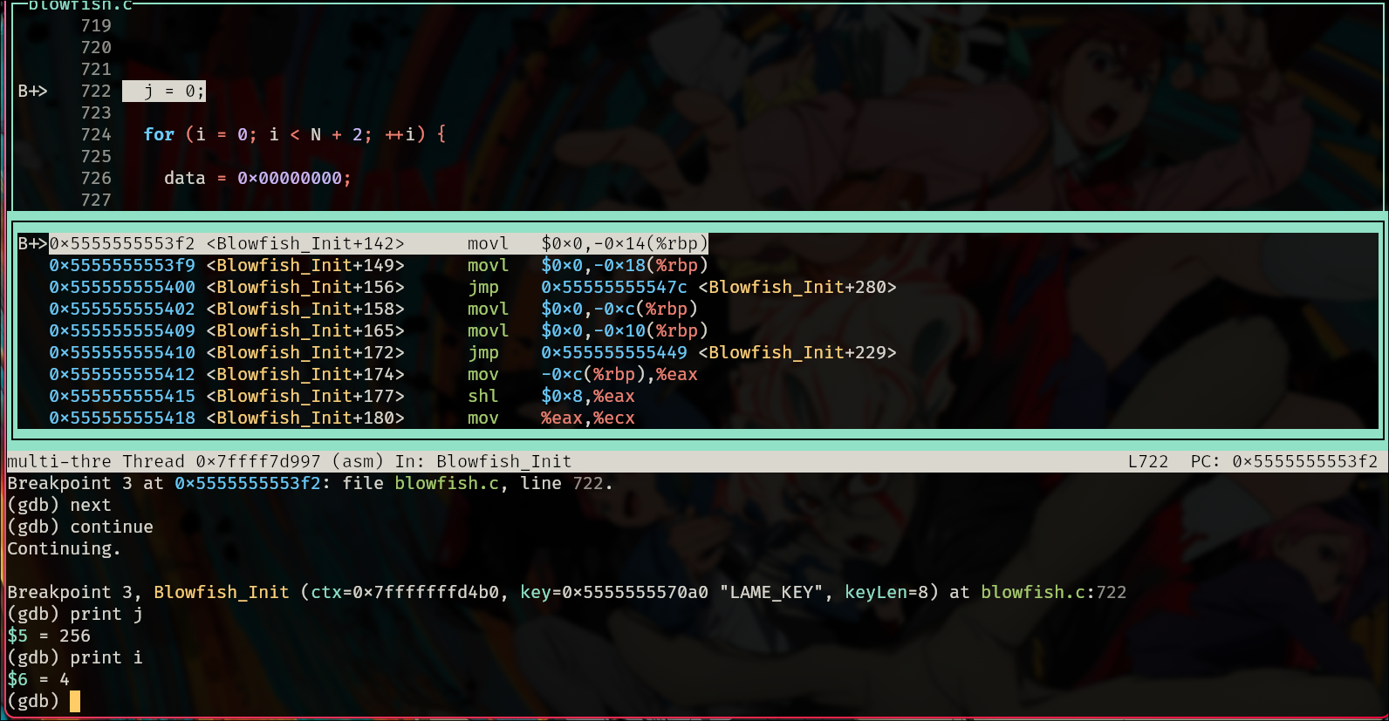
Q8: “stepi”, to go into the function, break to set a breakpoint after the for loop and continue to go to the breakpoint, after all that I printed the value of j and I.
Q9: $1 is hex, $2 is bin, $3 is float, $4 is character representation
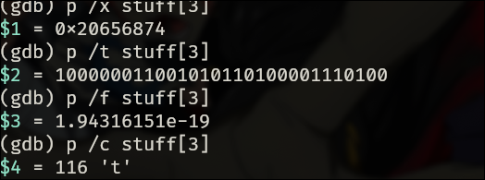

Q10: It seems like a song from The Muppets. It's about the people in your neighborhood.
Q11: $6 is the value of x.
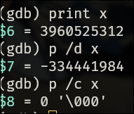

Q12: It looks like it shows the functions the current function is nested in, the step-ins it took to get to where it is it. It also shows the values of the local variables in the functions when they were entered.

